Greco Feudal – 1 Page GDD

# Overview

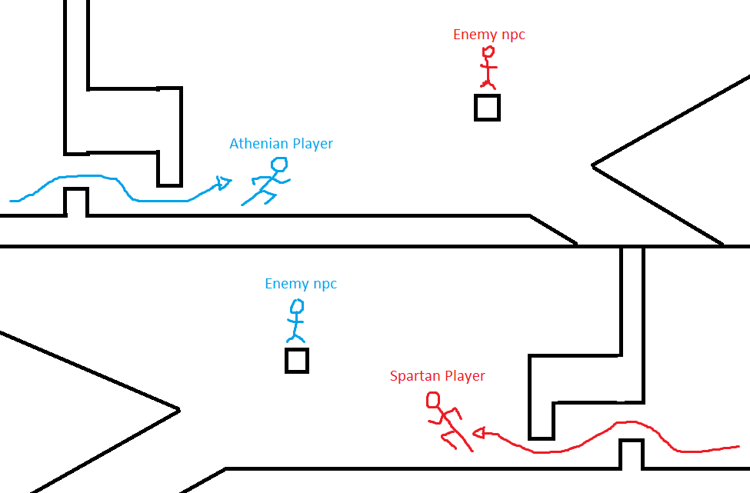Greco Feudal is a 2D action platformer where 2 players share a screen and run towards each other. They navigate a symmetrical map, facing enemies and obstacles along the way until they meet in the middle and have a climactic battle to decide a war.

# Pillars

1. Unique Culture Blend
2. Player vs Player
3. Rapid Gameplay

# Unique Selling Point

* A blend of cultures that hasn’t been explored before. A mix of Greek and Japanese culture that creates a new and interesting aesthetic.
* 2 players facing off in a rapid approach and duel that tests skills like coordination, judgement, and reaction time.
* Symmetrical gameplay on a single screen and keyboard.

# Target Market

This game is targeted towards people that:

* Like ancient history
* Enjoy fast paced games
* Want competitive aspects in games
* Don’t have a lot of free time

# Mechanics

* Run – player doesn’t control as you always move forward
* Jump – used to navigate obstacles and the multiple paths
* Slide – used to dodge obstacles
* Dagger throw – auto aims a long range attack at NPC enemy
* Slice – attacks NPC enemy directly in front of player
* Duel – players perform quick time button presses to fight each other

# Main Loops

